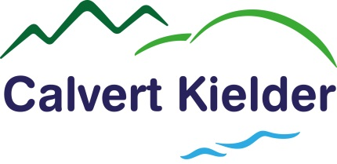

Photography & Filming Consent Form A

Calvert Kielder would like to use photographs and/or video recordings taken of you for use in promotional material. These images could be used in print and digital media formats including printed publications, website, posters, banners, advertising, research purposes and social media.

I understand that images on websites and social media can be viewed throughout the world and not just in the United Kingdom and that some overseas countries may not provide the same level of protection to the rights of individuals as EU/UK legislation provides.

I understand that some images or recordings may be kept permanently once they are published and be kept as an archive of Calvert Kielder life.

Calvert Kielder is committed to processing information in accordance with the General Data Protection Regulations (GDPR) 2018. The personal data collected on this form will be held securely and will only be used for administrative purposes. We will not use the images taken, or any other information you provide, for any other purposes than those stated above.

Consent

Please confirm your consent by placing an X in the relevant boxes: | YES | NO | N/A
May we use your image/recording for the purposes stated above?
May we identify your image/recording?
May we use your child or children’s image(s)/recording(s) for the purposes stated above?
May we identify your child or children’s image(s)/recording(s)?

Details of Person Giving Consent

Full Name
Signature |  | Date

Your Rights

You have the right to request to see a copy of the information we hold about you and to request corrections or deletions of the information that is no longer required. You can ask Calvert Kielder to stop using your images/ recordings at any time, in which case they will not be used in future publications but may continue to appear in publications already in circulation. Calvert Kielder cannot control already published material or recall it.

If you have any questions relating to this consent form or the way we are planning to use your information or you wish to withdraw your consent at any time you should e-mail - marketing@calvert-kielder.com

If you have any questions relating to data protection please contact Calvert Kielder’s Data Protection Officer at data.protection@calvert-kielder.com

Please complete this form in full and return it to:

Calvert Kielder, Kielder Water & Forest Park, Hexham, Northumberland, NE48 1BS.

Tel: 01434 250232 Fax: 01434 250015 Email: marketing@calvert-kielder.com

Registered Charity No. 511851. Company limited by guarantee. Registered in England No. 1596913

