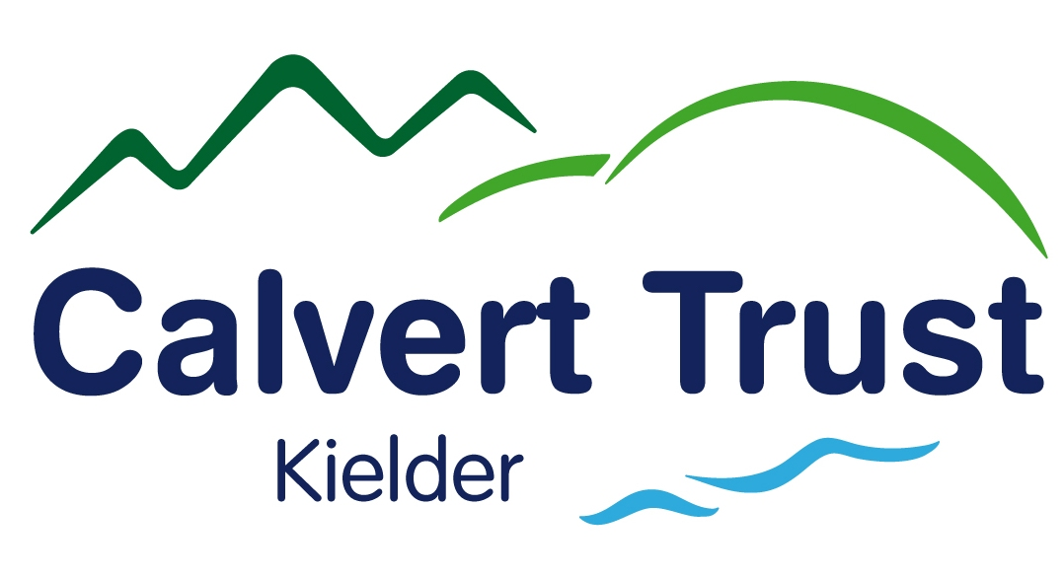

Our local therapist Simon will visit and provide the treatment/s you require. Please note that Simon runs his own private business and bookings must be made in advance and are subject to his availability. Please do not send any money in advance, please pay after your treatment. Full cancellation charges are applied, for bookings cancelled less than 48 hours before treatment.

Please choose from the selection of treatments detailed below, complete the booking form and return this prior to arrival.

REFLEXOLOGY - £36.00 – A very relaxing treatment creating a feeling of well being through working the bodies’ reflexes located in the feet.

FULL BODY MASSAGE - £36.00 – A treatment for arms, legs, back and front and finishing with the back.

BACK MASSAGE – £26.00 - A very relaxing experience or can be firmer to meet your needs.

FOOT and LEG MASSAGE - £26.00 – Soothing and calming treatment for aching limbs.

INDIAN HEAD MASSAGE - £26.00 – Relaxing and soothing for head, neck and shoulders.

------------------------------------------------------------------------------------------------------------------------

Holistic Therapies

Name: ………………………………………………………………………………………………

Treatment Required: …………………………………………………………………………….

Dates of holiday: ……………………………………………………………………………….

.

Calvert Trust Kielder, Kielder Water & Forest Park, Hexham, Northumberland NE48 1BS
Telephone: 01434 250232 Fax: 01434 250015 Email: enquiries@calvert-kielder.com
Company Registration 1596913 Charity Registration 511851

